Metro Blooms – Marketing Site – Specifications & Usage Guide

Zach Iniguez

The Nerdery | 1555 James Ave S, STE 245, Bloomington, MN 55431

Prepared By:  Zach Iniguez

Date Created:  April, 2014

Date Modified: 4/27/2014

Document status: [ ] Draft [X] Proposed [ ] Approved

# Revision History

|  |  |  |  |
| --- | --- | --- | --- |
| Date | Version | Author | Notes |
| 04/27/2013 | 1.0 | Zach Iniguez | Document created |

# Table of Contents

Revision History 1

Table of Contents 2

Audience 4

Background 4

Purpose 4

Technical Information 4

Credentials, Hosting, and Repository 5

Important URLs 6

Maintenance 6

Pages 7

Updating a Page 7

Adding a Page 7

Removing a Page 9

Sections 9

Types of Sections 9

Updating a Section 10

Adding a Section 10

Removing a Section 10

Media 11

Adding Media 11

Using Media 11

Removing Media 12

Audience

This document is intended to be seen by any Metro Blooms organization member who will be in charge of administering the marketing website.

# Background

Metro Blooms sought the assistance of the Overnight Website Challenge to assist with its internet initiatives. Over 24 hours the team of Full Stop Net worked with Becky Rice to perform UX, visual design, and development of a new educational/marketing site.

# Purpose

The purpose of this document is to provide a practical guide to using and maintaining the Metro Blooms marketing website. Becausee the Metro Blooms site is built with Microsoft ASP.NET and the Umbraco CMS some knowledge of those systems is expected in order to administer the site. This guide does not provide training for administering Umbraco itself. Rather, it is meant to provide information specific to the Metro Blooms marketing website and its customizations.

# Technical Information

The Metro Blooms marketing site is built with Umbraco 6.1.6 on the MVC4 platform. The solution Is built with Visual Studio 2013 on the .NET Framework 4.5.

Within the Metro Blooms solution are two projects--MetroBlooms and MetroBlooms.Api. The MetroBlooms project contains the supporting code for the website itself, including the interactions with Umbraco and all related front-end assets (CSS, JavaScript). The project does not contain the Umbraco CMS code Itself, however that is located within the repository and will need to be deployed with the project. The MetroBlooms.Api project is used to consume data from the Metro Blooms API. Currently it is used for consuming Event information on /get-involved/events/. This project could easily be extended to GET or POST to other components in the API.

The solution contains deployment profiles to Dev (fullstopnet-dev.azurewebsites.net) and a front-end sandbox environment (fullstopnet-fe3.azurewebsites.net).

# Credentials, Hosting, and Repository

The following credentials are used for the hosting of the staging server and also for access the Umbraco administrative area.

|  |  |  |  |  |  |
| --- | --- | --- | --- | --- | --- |
| **System** | **Email** | **Username** | **Pass** | **First Name** | **Last Name** |
| Outlook/Azure |  | fullstopnet@outlook.com | //nsk`bm"gDm{/4K |  |  |
| Database (Azure) | Server: tcp:u8zv7a09yn.database.windows.net | fullstopnet@u8zv7a09yn | 73jkveKT0MR |  |  |
| Umbraco Admin | rice0708@gmail.com | rice0708 | bl00m | Rebecca | Rice |
| Umbraco Admin | holz13126@gmail.com | holz13126 | bl00m | Barb | Speltz |
| Umbraco Admin | laura.hurley@gmail.com | laura.hurley | bl00m | Laura | Hurley |
| Umbraco Admin | paul@dancingpaul.com | pstroot | bl00m | Paul | Stroot |

Currently the site is hosted with Microsoft Azure. In the coming weeks final migration will be moved to ipHouse, and the Azure-hosted staging site will be decomissioned. At that time this section will be updated.

In order to manage Azure hosting, please do the following:

* Visit https://manage.windowsazure.com
* Log in with the "Outlook/Azure" credentials above

This requires knowledge of Microsoft Azure administration, and it is recommended that changes not be made to this section.

Umbraco uses the database named "fullstopnet-dev". This will also be migrated to ipHouse and decomissioned. The database can accessed via SQL Server Management Studio by using the "Database (Azure)" credentials above.

The code repository uses Git an is hosted within a GitHub repository at https://github.com/zliniguez/OWC2014.FullStopNet/, working off of the develop branch. If access is required please request it through GitHub or email Zach Iniguez at zach.iniguez@gmail.com.

## Important URLs

The following URLs are used throughout the site editing process. You will encounter these frequently.

|  |  |
| --- | --- |
| **URL** | **Purpose** |
| http://fullstopnet-dev.azurewebsites.net | The current staging site. |
| http://fullstopnet-dev.azurewebsites.net/umbraco | The Umbraco-based administration area. |
| https://github.com/zliniguez/OWC2014.FullStopNet | The current code repository. |

# Maintenance

In order to make any changes to the site you first must login with your Umbraco account (see "Credentials" section) by visiting the admin area above. For content editors and administrators you will now have the ability to make text changes, add new pages, and add media.

In the lower-left of the administration area you will see this pane:

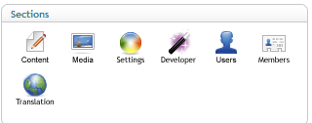

The "Content" area is where all public-facing pages, text, and sections will exist. "Media" stores the images used within the site. The other sections should be accessed by Umbraco-administrators only to update manage the CMS itself and users.

## Pages

Each page is represented by a node in the left panel. Expanding these nodes will show you all sections within displayed on that page, as well as its subpages.

### Updating a Page

To update a page simply click its node in the "Content" pane. Each page has two tabs: "Main Content" and "SEO". "Main Content" allows the user to select a Header Image, which is a large banner Image displayed across the top of the page. The "SEO" tab allows the user to set the page's meta information.

The "Home" page has special "Header" and "Footer" tabs, which set global information such as navigation, address, phone number, and more.

Underneath each page's node is a "_Sections" folder. The sections concept Is explained below, but this will allow the user to construct the components displayed on the page itself. One or more sections are necessary to display content on the page.

### Adding a Page

Pages must be added below the "Home" node or underneath another node. Simply right-click the node underneath you wish to add the page, click "Create Page", and enter the name of the new page. Ensure that "Generic" is selected as the document type. Then click create. At this point the page is created with no meta information, no sections, and is not published.

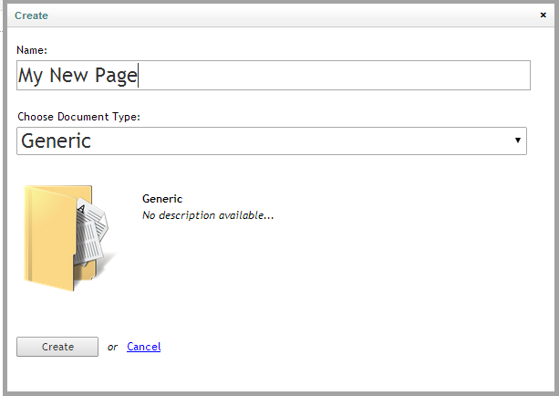

After the page is created you will need to add a new "_Sections" folder to contain the sections to be displayed on this page. Right-click on the new page and use the following Information to complete the process:

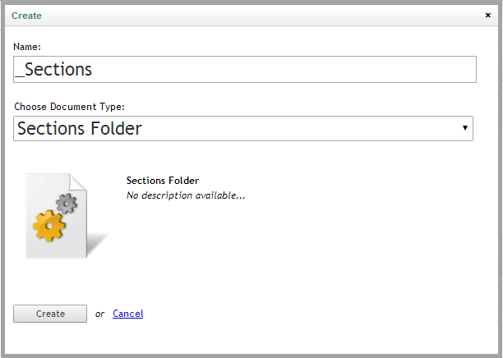

You will now see a "_Sections" folder underneath the new page, which you will use to add sections of content (as described below).

To complete the process fill out the relevant information, add sections, and finally right-click on the new page node and select "Publish". Any nodes with the star next to them indicate new content that has yet to be published. If you don't see your changes on the site, this is probably why!

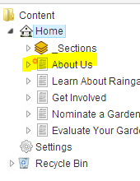

### Removing a Page

To remove a page simply right-click on Its node and select "Delete". This will remove the page and Its sections, but not the media used on those pages.

## Sections

A "section" Is a piece of content that is added and positioned on the page, and a page is comprised of one or more sections.

All sections exist within the "_Sections" folder within a page, and this folder must exist underneat a page to display content (see above for adding the "_Sections" folder to a new page.

### Types of Sections

|  |  |
| --- | --- |
| **Name** | **Purpose** |
| Call to Action | Displays an image next to content with a headling, text, and an optional call-to-action button.  Used on the homepage under the "Water Quality Affects Us All" section. |
| Content With Image | An image alongside content with an optional heading.  Used on the "About Us" page as "Our Goals". |
| Image Display | Displays up to three images side-by-side. |
| Quote | Displays a quote with an optional citation. |
| Rich Text | Displays rich text with an optional heading. Used for most standard content areas on the site. |
| Splash Content With Image | Displays an image, title, text, and call to action. Used on the homepage in various ways ("Addressing our clean water problem …", "Our Clean Water Problem", etc.") |

To re-order sections within a page simply drag-and-drop the sections nodes themselves, then Publish the page.

### Updating a Section

To update a section simply click into the "_Sections" folder within the page that has the section you'd like to update. All section properties are on the "Main Content" tab, which will be selected automatically. Each section type has its own set of properties, which are described with help text next to the property. After changes have been made simply click the "Save" button, then publish the page itself.

### Adding a Section

To add a section simply right-click on the "_Sections" folder, then click "Create". From here give the section a descriptive name, then under "Choose Document Type" select the type of section you'd like to add. Then click "Create", complete the section details, and publish your page.

### Removing a Section

To remove a section right-click on the section node you'd like to remove, then click "Delete". After publishing the page the section will be removed from the page.

## Media

The "Media" section in the lower-left "Sections" area is where images used throughout the site are added and removed.

### Adding Media

To add a new piece of media simply click the "Upload" button from the main window (highlighted below). Optionally you can create a new folder by right-clicking the "Media" or subfolder node on the left and clicking "Create".

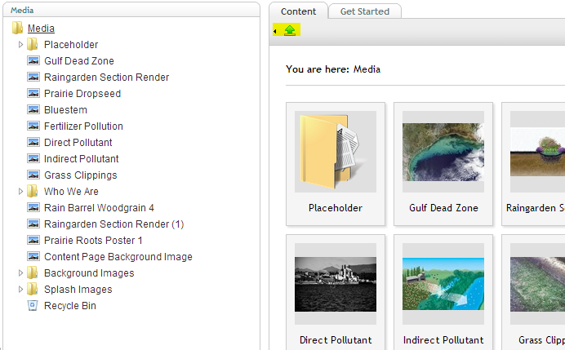

You can upload multiple pieces of media at a time. After the media has been uploaded It will appear within the left panel.

### Using Media

In order to display an image within a page (either the heading image, within the "Image Display" section type, or in a rich content area, it first must be uploaded to the media library. Once done, the media will now appear in the media selector.

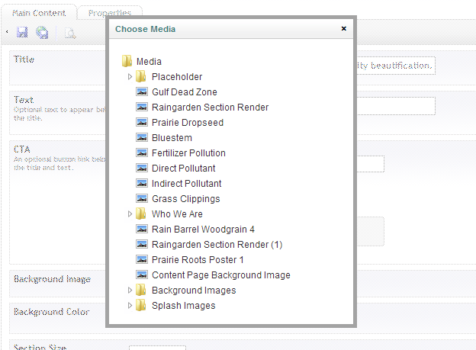

### Removing Media

To remove media simply right-click on the item and click "Delete". It will be removed from the media library and any page that uses it.